

**COLLEGE OF COMPUTING AND INFORMATION SCIENCES**

MAMABABY MIDWIFE SYSTEM **(**MMS**)**

By

Mubangizi kingedward

**DEPARTMENT OF COMPUTER SCIENCE**

**SCHOOL OF COMPUTING AND INFORMATICS TECHNOLOGY**

A Project Report Submitted to the School of Computing and Informatics Technology

For the Study Leading to a Project in Partial Fulfillment of the

Requirements for the Award of the Degree of Bachelor of Science in Computer Science

Of Makerere University

School of Computing and Informatics Technology, Makerere University

May, 2017

### APPROVAL

To the research

This report has been submitted for approval to the College of Computing and Information science, Makerere University supervisor.

**Name:** Mr. ERNEST MWEBAZE

**Lecturer:** Makerere University.

**Signature: …………………............**

**Date: ………......................................**

### ACKNOWLEDGEMENT

First of all, we thank the Almighty God the most gracious and most merciful for the wisdom and knowledge, the health and protection and all that he has bestowed on us so that this report becomes a success.

Sincere gratitude to our beloved parents and guardians for the spiritual moral and financial support accorded to us throughout the entire course of our education.

We thank our lecturer , our research for the support, patience and continuous guidance throughout the semester, which has brought out the best effort in us towards the accomplishment of this research.

Lastly, to all our classmates and lecturers of the School of Computing and Information Sciences who provided a good study environment and supported us throughout the entire program. It has been yielding sharing and learning from you all. May the Almighty God bless you and reward you accordingly.

# Table of Contents

APPROVAL ................................................................................................................................................ iii

ACKNOWLEDGEMENT ........................................................................................................................... iv

List of Tables ..............................................................................................................................................viii

List of Figures .............................................................................................................................................. ix

ABSTRACT.................................................................................................................................................. x Introduction ................................................................................................................................................... 1

1.1 Background ....................................................................................................................................... 1

1.2 Problem Statement ............................................................................................................................ 1

1.3 Objectives ............................................................................................................................................... 2

1.3.1 Main Objective .................................................................................................................................... 2

1.3.2 Specific Objectives .............................................................................................................................. 2

1.4 Scope ................................................................................................................................................. 2

1.4.1 Geographical Scope ............................................................................................................................. 2

1.4.2 Technical Scope ................................................................................................................................... 2

1.5 Significance ...................................................................................................................................... 3

2.0 Literature Review. .................................................................................................................................. 4

2.1 Introduction ............................................................................................................................................. 4

2.2 Review of the Current System ................................................................................................................ 5

2.2.1 Key concepts of partograph ............................................................................................................. 5

2.2.2 Merits ............................................................................................................................................... 5

2.2.3 Demerits ........................................................................................................................................... 5

2.3 Related existing systems/applications ..................................................................................................... 6

2.3.1 E-PARTOGRAPH ........................................................................................................................... 6

2.3.2 PARTOPEN ..................................................................................................................................... 6

2.4 Tabular comparison of the different systems. ......................................................................................... 6

2.5 Merits of the Mamababy Midwife System. ............................................................................................ 7

2.6 CONCLUSION ....................................................................................................................................... 7 Methodology ................................................................................................................................................. 8

3.1 Introduction ............................................................................................................................................. 8

3.2 Research design ...................................................................................................................................... 8

3.3 Study population ..................................................................................................................................... 8

3.4 Sampling procedure ................................................................................................................................ 9

3.4.1 Sampling methods ............................................................................................................................ 9

3.5 Data collection methods ......................................................................................................................... 9

3.6 Requirements Identification. ................................................................................................................. 10

3.7 Data Analysis ........................................................................................................................................ 10

3.8 System Design...................................................................................................................................... 10

3.9 System Implementation ........................................................................................................................ 10

3.10 System Testing and Validation........................................................................................................... 11 System Analysis and Design....................................................................................................................... 12

4.0 System Study ........................................................................................................................................ 12

4.0.1 Existing system .................................................................................................................................. 12

4.0.2 Strength of the existing system .......................................................................................................... 12

4.0.3 Weaknesses of the existing system .................................................................................................... 13

4.1 System Analysis .................................................................................................................................... 13

4.1.1 Results of Questionnaires .................................................................................................................. 13

4.1.2 Interviews ........................................................................................................................................... 13

4.2.1 User Requirements............................................................................................................................. 14

4.2.2 Functional Requirements ................................................................................................................... 14

4.2.3 Non-Functional Requirements........................................................................................................... 15

**PERFORMANCE REQUIREMENTS** ............................................................................................................ 15

4.3 System Design...................................................................................................................................... 17

4.3.1System Architecture ............................................................................................................................ 17

4.3.2 Use Case Diagram............................................................................................................................. 18

4.3.3 Entity Relationship Diagram.............................................................................................................. 18

CHAPTER FIVE ........................................................................................................................................ 21 Presentation of results and findings ............................................................................................................ 21

5.0 Results of Data Collection and Analysis .............................................................................................. 21

5.1 User Interfaces and Screenshots........................................................................................................... 21

5.2 Results of Testing ................................................................................................................................. 22

CHAPTER SIX ........................................................................................................................................... 23 Conclusions and Recommended Future Works .......................................................................................... 23

6.0 Achievements ........................................................................................................................................ 23

6.1 Limitations............................................................................................................................................ 23

6.2 Recommended future work ................................................................................................................... 24

6.3 Conclusion............................................................................................................................................ 24

References ................................................................................................................................................... 25

Appendix A. ................................................................................................................................................ 26

Appendix B ................................................................................................................................................. 27 Appendix C. ................................................................................................................................................ 29

Appendix D ................................................................................................................................................. 29

### List of Tables

Table 2.1 Comparison of different systems------------------------------------------------------------------------- 6

Table 4. 1: Software requirements ---------------------------------------------------------------------------------------16

Table 4. 2 Hardware Requirements------------------------------------------------------------------------------- 17

### List of Figures

Figure 4. 1 System Architecture------------------------------------------------------------------------------ 17

Figure 4. 2 Use case Diagram--------------------------------------------------------------------------------- 18

Figure 4. 3 Entity Relationship Diagram--------------------------------------------------------------------- 20

### ABSTRACT

This report is comprised of six broad chapters that discuss various aspects and activities that were carried out during the course of this project which firstly, introduces the concept of the latest Information Communications Technology trends in relation to diagnosing obstructed labor in particular.

Working from observation, data collection and analysis were instrumental in identifying user requirements of the system in development. This was carried out in two methods, reasons for which are stated in this report; interviews, and questionnaires. Analysis of the collected data was performed using the software-based tool „SPSS‟ from which important conclusions about the desired functionality of the system were made.

Methodology used in the development in this system included Xamp and JavaScript for developing the user interfaces. The components of the interfaces were organized and styled using CSS. The system was developed using Java script running on the Phone gap Platform. Phone gap was chosen mainly because of its good documentation. The database was run using MySQL. This system was tested to check for faults and errors. System testing was done in two ways; that is component testing, where the different parts of the system are tested independently, and system testing, where the entire system is tested as a whole.

Achievements and limitations faced during the course of this project are attached to this report, alongside conclusions and recommended future works.

Introduction

## 1.1 Background

The WHO through its team of experts has developed several tools to aid the developing countries and boost their crippling health service delivery systems (World Health Organization, 2015). Among the very many tools is the partograph. The Partograph is a composite graphical record of key data (maternal and fetal) during labour entered against time on a single sheet of paper (Wikipedia, 2015). The partograph was designed to improve maternal health, which is the fifth Millennium Development Goal (MDG).

As an obstetric tool, its usefulness and efficiency cut across resource-poor and developed nations (World Health Organization, 2015). Evidence abounds that the acquisition of knowledge of its use and ensuring proper application of that knowledge would culminate in a remarkable reduction in the incidence and outcomes of prolonged and obstructed labor, which are reported to be associated with 8%–10% of maternal deaths (World Health Organization, 2015).

It is also true that the several key steps taken to ensure safety of mothers in the labour suit coupled with mid-wives’ and nurses’ fatigue can lead other steps to being forgotten about.

## 1.2 Problem Statement

Over the past years in Ugandan Health Centers, there has been a WHO standard partograph that was introduced to manage the prolonged and obstructed labor that is encountered by pregnant mothers but the technical knowledge of the use of the partograph for labor management and even proper interpretation of the partograph information is very complicated among nurses and midwives working in the primary and secondary health care levels and private health care centers when compared to tertiary level care (Fawole, 2008). This is because some midwives do not have the skills required to operate the partograph due to low levels of education and also some midwives consider it a time consuming activity.

In addition, lack of charts in the labour ward and poor managerial support regarding the procurement of necessary supplies has hindered the use of partographs.

It is therefore from this concern that the researchers have come up with idea of developing Mamababy Midwife System (MMS) that will diagnose obstructed labour and provide supportive explanatory information for easy monitoring and success rate during the difficulties of obstructed labor.

## 1.3 Objectives

#### 1.3.1 Main Objective

To develop Mamababy Midwife System (MMS) that could diagnose obstructed labor and provide supportive explanatory information for easy monitoring and prevention of obstructed labor.

#### 1.3.2 Specific Objectives

1. To study and investigate the current system in order to analyze the user and functional requirements for the MMS.
2. To design the MMS.
3. iii) To implement the MMS.

iv) To test and validate the MMS.

## 1.4 Scope

#### 1.4.1 Geographical Scope

This system is intended to cover health institutions in Uganda mainly health centers IV and V since “the beginning justifies the end”. A case in point is Mulago Hospital which will be the researcher’s case study and that’s where data will be gathered, analyzed and managed for further important roles.

#### 1.4.2 Technical Scope

The Mamababy Midwife System is based on the android mobile platform with a Xamp server and MySQL database for storing the input parameters and an embedded device (sensors) for collecting and recording fetal heart rate.

This Mamababy Midwife System is a mobile based and an online system where midwives will be entering the required data for the app to produce diagnosis results which will guide them in decision making while using their devices which are android based. Furthermore, the system will be accessed on smart mobile phones as long as they can access internet which is likely to save midwives’ time to plot the partograph and also to share data. The Mamababy Midwife System will be one of the implementations of ICT as far as improvement of health conditions is concerned.

## 1.5 Significance

The Mamababy Midwife System will be used by the midwives to ease the process of diagnosing obstructed labor in order to exhibit greater performance and excellence.

The system will be cost effective to both the institutions’ administration and the government since the process of labour monitoring will be effectively done once the Mamababy Midwife System is well implemented.

This system is likely to boost the use of currently changing technology since the partograph information such as the mothers details will be accessed on smart phones thus improving the understanding of midwives to such upcoming technologies as Uganda hopes to achieve Vision 2040 through promotion of Information Communication and Technology (ICT).

It will also become a source of information that could later on be referenced in the research work about the midwives’ health support systems.

2.0 Literature Review.

This chapter consists of a critical review and analysis of research work from Internet sources, published articles, reports, journals and other published books related to Mamababy Midwife System. The aim was to discover information and ideas that may be relevant to this project and identify contributions, weaknesses and gaps.

## 2.1 Introduction

Prolonged labor is a leading cause of death among mothers and newborns in the developing world. It is most likely to occur if a woman’s pelvis is not large enough for her baby’s head to pass through or if a woman’s uterus does not contract sufficiently. If her labor does not progress normally, the woman may experience serious complications such as obstructed labor, dehydration, exhaustion, or rupture of the uterus. Prolonged labor may also contribute to maternal infection or hemorrhage and to neonatal infection. (AMRN, 2003)

Skilled management of labor using a partograph, a simple chart for recording information about the progress of labor and the condition of a woman and her baby during labor, is key to the appropriate prevention and treatment of prolonged labor and its complications. Following the recommendation of the World Health Organization (WHO), the Maternal and Neonatal Health (MNH) Program promotes the use of the partograph to improve the management of labor and to support decision-making regarding interventions. When used appropriately, the partograph helps providers identify prolonged labor and know when to take appropriate actions. (Lancet, 1994)

This study will explore Mamababy Midwife System adoption intentions in relation to the traditional manual partograph carried. This was intended to demonstrate the success of the partograph model by providing value to both mothers and hospitals.

## 2.2 Review of the Current System

###### 2.2.1 Key concepts of partograph

Three major parameters are captured during active labor that is Path (Rate of cervical Dilatation, measured every 4hours), Power (Number of contractions in every 10 minutes) and Passenger (State of the foetus, measured every 30 minutes through the fetal heart rate).

The midwife is expected to measure these parameters using locally available tools like a local stereoscope to measure fetal heart beat. This information is then recorded in figures onto the partograph against time.

The state of the mother and fetus is determined using the proceeding graph using the alert line and the other two graphs.

###### 2.2.2 Merits

* All Data during labor is recorded on the same sheet of paper. This eases the process of monitoring the state of woman and fetus.
* Cheap and so can enhance labor monitoring in low resource areas.
* No need to record labor monitoring on the same piece of paper.
* Facilitates improvement in maternal mordibility, perinatal mordibility and mortality.
* Prediction of deviation from normal progress of labour.

###### 2.2.3 Demerits

Non availability of printed partographs as a result of complicated procedures to acquire them from authorities for example Ministry of Health.

Plotting of curves is complicated. Some midwives did not attain high level education therefore it’s hard to interpret resulting into poor monitoring of labor.

Lack of information sharing. Information cannot be shared easily between hospitals and this affects the decision making process necessary to reduce effects of obstructed labor.

## 2.3 Related existing systems/applications

#### 2.3.1 E-PARTOGRAPH

A method of monitoring the progress of labor in a mother during childbirth, by attaching a position sensor to a predetermined point on the mother's pelvic bones; monitoring the location of the position sensor in three- dimensional space relative to a reference; and monitoring the location of the fetal presenting part with respect to the predetermined point on the mother's pelvic bones. (JANI, 2007) However the E-partograph is very expensive to the developing countries, it’s not mobile which not the case with Mamababy Midwife System.

#### 2.3.2 PARTOPEN

The PartoPen is a low-cost, interactive digital pen that interprets paper partographs printed with a recognizable background dot pattern. Using internal handwriting recognition and paper-based location awareness, the pen analyzes measurements made on partographs. It can trigger alerts to healthcare workers when it recognizes a need for additional observation or intervention and contains timers that serve as reminders for healthcare workers to take routine, regular patient measurements. It can also provide audio-based instructions on how to use the partograph. Retains the current paper-based labor-monitoring system already widely used in developing countries (INTERNATIONAL, 2014).However PartoPen is not readily available.

## 2.4 Tabular comparison of the different systems.

|  |  |  |  |
| --- | --- | --- | --- |
| FEATURE | Mamababy Midwife  System | E-PARTOGRAPH | PARTOPEN |
| Availability | M | L | L |
| Usability | H | L | M |
| Cost | M | H | H |
| Obstructed labor prevention | H | H | H |

Table 2.1 Comparison of different systems

**Key:** H= High L= Low M: Moderate

# 2.5 Merits of the Mamababy Midwife System.

Inexpensive technology which is mobile.it can be used anywhere and at any time on any android platform.

Helps in continuity of care and providing information. Analyzing results is easy due to the consistent alerts to the midwives.

Easy Handover Procedure. Midwives can easily hand over the progress results of labor to the doctors or other midwives for the next shift.

It also saves time because there is no need to draw and plot a partograph.

## 2.6 CONCLUSION

The labor period is probably the most dangerous and traumatic period – a time associated with a high mortality and morbidity for both mother and child. Maternal and fetal monitoring are essential to pick up problems early and thus institute timely intervention. When the partograph is used correctly it improves maternal and perinatal mortality rates. Can serve as an “early warning system” & assist in making timely decisions on transfers (referrals), intervention (augmentation) &/or termination of pregnancy.

Methodology

## 3.1 Introduction

This chapter highlights the detailed description of the selected methods that were used to achieve the stated objectives as well as the research design, project requirements, instruments and the data collection methods.

## 3.2 Research design

This research was basically designed following the requirements for the implementation of Mamababy Midwife System. This involved formulation of the research questions that will give a clear reflection of how information about the performance of Mamababy Midwife System in hospitals will perform. The following were some of the research questions that the researcher used while formulating the research design for this project.

1. Can the use of ICT help to reduce obstructed labor through the use of partograph in Ugandan hospitals?
2. What does it take someone to cope up with use Mamababy Midwife System?
3. Does Mamababy Midwife System constitute to the ways of achieving the child and maternal health as one of the millennium development goals?

## 3.3 Study population

Respondents from Mulago Hospital were used for gathering information. The gathered information was analyzed and quantified. The researcher used this area as a case study since it is near Makerere University and it uses the partograph .The researcher intended to use a sample population of 30 respondents which included the midwives only.

## 3.4 Sampling procedure

This involves selecting units like people, organizations from a population of interest so that by studying the sample, fairly generalize the results back to the population from which will be chosen. This will be probability sampling where each population element has a known (nonzero) chance of being chosen for the sample in a sample or non-probability sampling where the probability that each population element will be chosen is not known and each population element has a non-zero chance of being chosen in a sample.

#### 3.4.1 Sampling methods

This where we basically used probability sampling methods in which case were stratified particularly stratified sampling.

**Stratified sampling**

In this research, we divided the population into sub-groups (or strata) that all share a similar characteristic in their education levels. We used this method because it has a high statistical precision, it also means that it requires a small sample size which can save a lot of time, money and effort of researchers.

In a stratified sample, the probability of an item being included varies according to known characteristics, such as robustness, effectiveness, educational attainment and the aim is to ensure that we can representatively sample even the smallest and most inaccessible subgroups in the population. This allows the researcher to sample the rare extremes of the given population.

# 3.5 Data collection methods

In case studies, data collection was treated as a design issue that enhances the construct and internal validity of the study as well as the external validity and reliability. (Yin, 1991) identified primary sources of evidence for case study research which are documentation, archival records, interviews, direct observation, participant observation and physical artifacts. It is to be noted that not all sources are essentially required in every case study; however, the importance of multiple sources of data to the reliability of the study is well established. Data Collection is an important aspect of any type of research study. Inaccurate data collection can impact the results of a study and ultimately lead to invalid results.

As far as data collection is concerned for our case study, we used interviews and observations in order to clearly understand the critics behind network simulation on the both scalable and nonscalable wireless ad-hoc network.

## 3.6 Requirements Identification.

This constitutes the very first step in the waterfall model. It starts with requirement analysis and checking whether the project is actually feasible with the present technologies or not. Requirements were gathered, analyzed and then proper documentation was prepared which helped further in the development process. In this process, we used questionnaires, interviews and observations in order to gather the requirements for the proposed system.

## 3.7 Data Analysis

The data that was collected from the field, was recorded that is coded for data content and where necessary transcribed. Recording of data included editing for language and tape recorded data.

The data collected was mainly described, categorized and classified according to concepts and symbols. This process involved naming, labeling and qualifying variables such as the time taken to draw the partograph.

## 3.8 System Design

The design of the system was done using a Use case diagram that helps to specify and explain the interaction between the actors and the system. The sequence diagram was used primarily to show the interactions between objects in the sequential order that those interactions occur. The Entity- Relationship diagram shows the relationships and entities in the mobile application.

## 3.9 System Implementation

In terms of implementation, we used Json and Xamp server which connects interfaces to the database and (JavaScript) for designing interfaces in order to effectively develop the system. We also used Android studio platform so as to effectively connect the database and the web interfaces.

## 3.10 System Testing and Validation

In this stage of development, we executed the application to see if the results conform to the user expectation and technical specification through presenting the system to intended users and allowing them to interact with the system. On the other hand, we carried out component testing, testing of individual components then integrate the components to form the whole system and then test it. This process was done to check for errors in the system and ways of rectifying them so that it really performs as expected by the users.

To validate, sample data was fed into the application to find out if the system will be able to respond according to the data entered. This gave a clear reflection of the user requirements.

### System Analysis and Design

This chapter describes and verifies strengths and weaknesses of the existing system. It highlights the requirements of the developed system and its design.

### 4.0 System Study

#### 4.0.1 Existing system

Three major parameters are captured during active labor that is Path (Rate of cervical Dilatation, measured every 4hours), Power (Number of contractions in every 10 minutes) and Passenger (State of the foetus, measured every 30 minutes through the fetal heart rate).

The midwife is expected to measure these parameters using locally available tools like a local stereoscope to measure fetal heart beat. This information is then recorded in figures onto the partograph against time.

The state of the mother and fetus is determined on the proceeding graph using the alert line and the other two graphs.

#### 4.0.2 Strength of the existing system

1. All Data during labor is recorded on the same sheet of paper. This eases the process of monitoring the state of woman and fetus.
2. Cheap and so can enhance labor monitoring in low resource areas. iii. No need to record labor monitoring on the same piece of paper. iv. Facilitates improvement in maternal mordibility, perinatal mordibility and mortality.

v. Prediction of deviation from normal progress of labour.

#### 4.0.3 Weaknesses of the existing system

Non availability of printed partographs as a result of complicated procedures to acquire them from authorities for example Ministry of Health.

Plotting of curves is complicated. Some midwives did not attain high level education therefore it’s hard to interpret resulting into poor monitoring of labor.

Lack of information sharing. Information cannot be shared easily between hospitals and this affects the decision making process necessary to reduce effects of obstructed labor.

### 4.1 System Analysis

We carefully studied requirements gathered from potential users and always got back for feedback on any new component or even if it was just a recent implementation, so that the system can remain useful to its users and not serve the purpose of the developer only. We had to weigh the pros and cons of various suggestions in the requirements gathered from potential users so that we pick the best compromise from a set of similar or related suggestions from users which was of great help. This section contains the requirements of the system which were categorized into functional requirements, user requirements and non-functional requirements based on the results of analysis of the data collected.

#### 4.1.1 Results of Questionnaires

The questionnaire survey was carried out at random selection around the Mulago hospital environment. Eight questions were asked which led us to the following analysis:

i.Most of the midwives have ever used a partograph.

ii.Sometimes it is not helpful during labor especially during emergencies.

iii.Most of the midwives have used a partograph between 2-5 yrs. iv.Most of the midwives take 30-40 min to draw a partograph.

v.Sometimes they use a partograph for every delivery they perform. vi. They find it difficult to use a partograph correctly because of its tedious activities.

#### 4.1.2 Interviews

These were carried out in Mulago Hospital with director of the department. The general responses are shown below;

i. A partograph is a major tool used to monitor labor in the hospital and also used to determine the health of the mother and the baby. ii. Sometimes the midwives don’t use the partograph because of being tedious to draw and plot the graph. Also its interpretation is difficult.

iii. Most of the midwives don’t prefer using partographs in monitoring labor because of its tedious activities.

#### 4.2.1 User Requirements

From the system study, the system stakeholders were identified and these were all random midwives who are computer literate. Their respective requirements are:

1. A system that is user friendly.
2. A system that the users can use to monitor the progress of labor of all pregnant women within the hospital.
3. A system with high security features that would allow only authorized users to access it.

#### 4.2.2 Functional Requirements

Functional requirements define the fundamental actions of the system and contain all the information of the software requirements for the development of MamaBaby Midwife support system. These include the following;

* The system stores patient’s bio data into the database. This enables retrieving, viewing and manipulation of patient details by the midwife
* The system allows parameter input from the midwife which includes the rate of cervical dilatation, fetal heart rate and number of contractions which are used to indicate the progress of labor.
* The system provides reminders to the midwife for each specific parameter since they are measured at different intervals.
* The system provides feedback to the midwife about the state of the pregnant mother and the foetus .e.g. “Fetal distress detected. Possible cause low contractions.”
* The system enables sharing of the critical patient data between specific health centres in case of referral.
* The software to be developed accepts output from sound sensor placed on the mother’s belly to record fetal heart rate.
* The software to be developed shall display graphical images on the screen when a reminder beeps to help the midwife know which parameter to test. E.g. two fingers will be displayed on the screen to indicate that the reminder is to test cervical dilatation.

#### 4.2.3 Non-Functional Requirements

This includes constraints that must be adhered to during the system development

**PERFORMANCE REQUIREMENTS**

* Performance shall be handled by microprocessor
* The system shall support the midwife in computing parameters against time.
* Data retrievals inform of a notifications to the user shall be readily available.
* The algorithms used by in the system will be highly efficient, taking only a fraction of a minute to compute.

**USABILITY**

A new user must find the functions easily that he is looking for on the system. EXAMPLE: If a new midwife wants to get information about the patient, so these details should be categorized in a way which makes it easy for the midwife to access them. The layout and performance of functionalities of the system should be pleasing to the user. The system should also look professional, representing the functionalities in a categorized manner.

**EFFICIENCY**

As there can be various requirements accessed by the users, the system may need some specific updating. But no too much time should be spent on updating. There can be some functionality which decreases the human work and automatically responds to the user’s requirements.

**ADAPTABILITY**

The system should be able to easily accept the changes. If any time something new is introduced to system, it is necessary that it can accept the changes easily.

**EXTENSIBILITY**

When we develop system, it should be created in a way which would support the extensibility. If a new entity or patient detail is to be added, the procedure should be easy and less time consuming, there can be also multiple functionalities added for doing it.

### 4.4 System Requirements.

In order for the system to perform as expected, the following system specifications for hardware and software are required:

Software Requirements for the system are shown in the following Table:

Software Requirements for the system are shown in Table 4.1

|  |  |
| --- | --- |
| SOFTWARE | MINIMUM SOFTWARE REQUIREMENTS |
| 1. Mobile phone Software | Android operating system |
| Database | MYSQL |
| Web server | Apache web server |

*Table 4. 1: Software requirements*

Hardware requirements for the system are shown in Table 4.2

|  |  |
| --- | --- |
| HARDWARE | MINIMUM HARDWARE  REQUIREMENTS |
| Processor | 400MHz to 1GHz |
| RAM | 128MB |
| INTEL EDSON |  |

*Table 4. 2 Hardware Requirements*

### 4.3 System Design

Process modelling/Conceptual design: Involves the use case diagram and Entity Relationship diagrams below.

4.3.1

System

Architecture

Figure 4.

1

System

Architecture

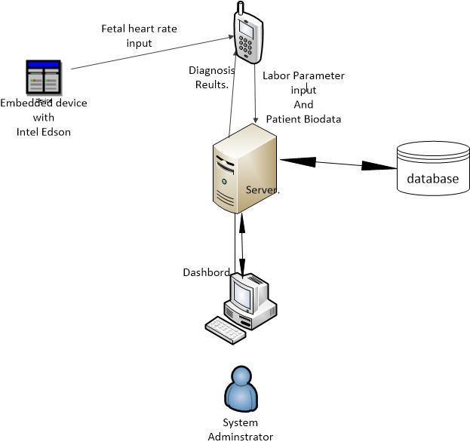

###### 4.3.2 Use Case Diagram

|  |
| --- |
|  |

Figure 4. 2 Use case Diagram 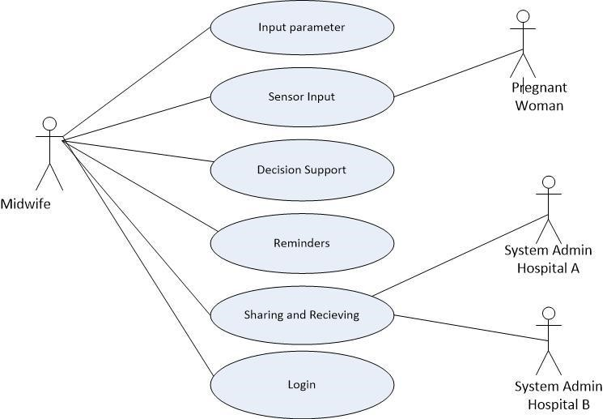

###### 4.3.3 Entity Relationship Diagram and their cardinalities.



This is a one- many relationship, where a hospital can have one or many words.



This is a one- many relationship, where a hospital can have one or many system administrators.



This is a one- many relationship, where a ward can partake one or many patients.



This is a one- many relationship, where a ward has one or many nurses.



This is a one- many relationship, where a patient can have one or many status.



This a one- many relationship, where a patient can have one or many parameters.



This a one- many relationship, where a nurse can receive one or many reminders.



This is a one- many relationship, where a nurse can check one or many status.

Figure 4. 3 Entity Relationship Diagram

Entity Relationship Diagram

.

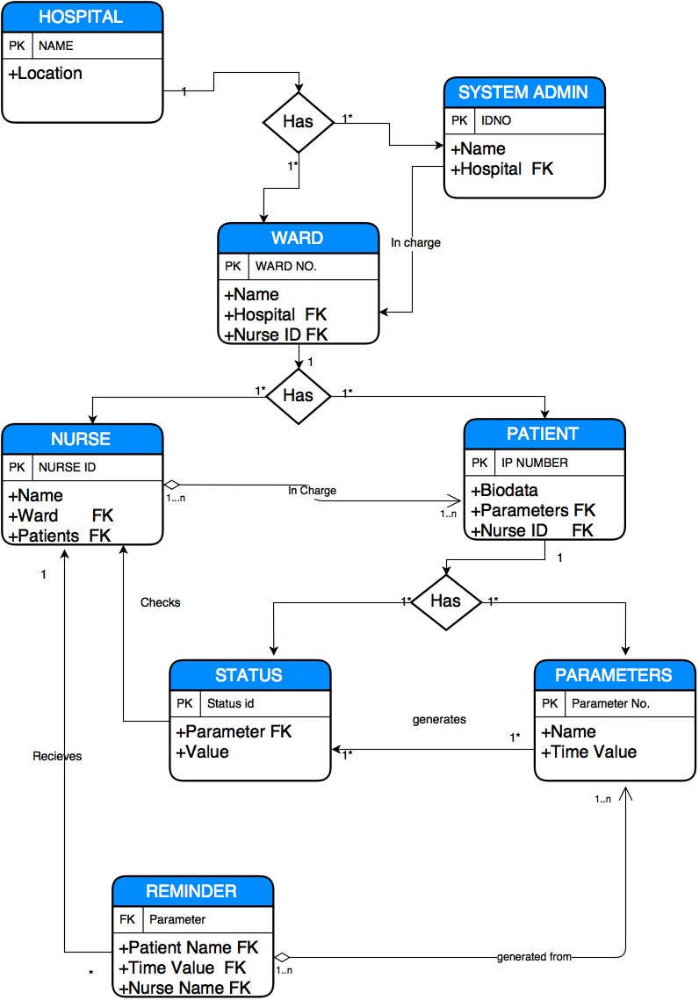

### CHAPTER FIVE

### Presentation of results and findings

This chapter discusses the conversion of the above design into a proper working mobile application. It shows the presentation of the design solution implemented in chapter 4 to meet requirements of the proposed system. The researchers designed form the Login, Inpatient, parameters and diagnose screens to be used for the new system in place. These forms were intended to ensure accurate completion of the system and keeping the system attractive to users.

### 5.0 Results of Data Collection and Analysis

From the analysis of the data collected the following conclusions were made:

* A partograph is a major tool used to monitor labor in the hospital and also used to determine the health of the mother and the baby.
* Sometimes the midwives don’t use the partograph because of being tedious to draw and plot the graph. Also its interpretation is difficult.
* Most of the midwives don’t prefer using partographs in monitoring labor because of its tedious activities.

### 5.1 User Interfaces and Screenshots

Xamp, JavaScript, android, CSS and MySQL were used in implementation of the system which helped to bring the system to life. Authentication, apps main function, inpatient page, help page and input parameters page of the mobile application shown in Figures 5.1, 5.2, 5.3, 5.4 and 5.5

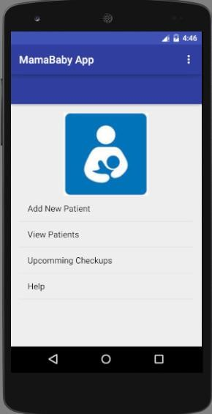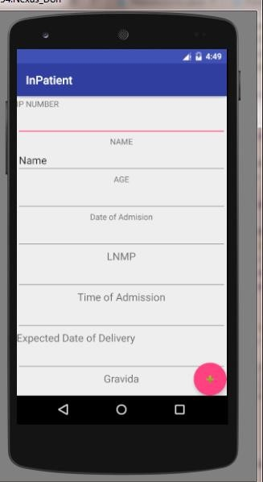

respectively.

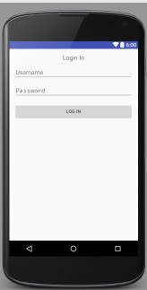

Figure5. 1 Login Page Figure5. 2 Apps main functions *Figure5. 3 Inpatient Page*

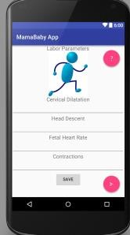 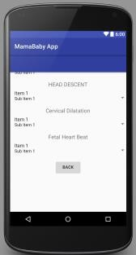

Figure5. 4 Input Parameters Page *Figure5. 5 Help Page*

### 5.2 Results of Testing

The results were got from different testing phases that were conducted during system implementation.

**Component testing:** In this case, tests were carried out on different units that make up the system. The main units were tested independently were Login, saving patients details and the diagnosis process.

In the Login, tests involving whether users had right credentials and whether they had an accounts in the application were done

In the saving patients details, tests whether all parameters are in an accepted manner.

In the diagnosis Process, Tests were carried out to check whether input parameters such as cervical dilatation and fetal heart rate are accepted as valid figures and give correct diagnosis results.

**System testing:** In this case, tests were carried out on the entire system done after all the components were integrated. This was to ensure that all units function effectively as a single system.

### CHAPTER SIX

##### Conclusions and Recommended Future Works

This chapter gives a general insight into the aspects of the system talked about in this report, and ideas possibly to be developed from it for future works.

##### 6.0 Achievements

These are the achievements of the development team during the buildup of the mobile application.

The development team was able to come up with a system that allows midwives to diagnose obstructed labor.

The development team produced an application that can help financial institutions to cut down on the cost of purchasing partograph.

### 6.1 Limitations

These limitations of the development team during the buildup of the mobile application. The financial resources required to support the development team during the project development process were not sufficient enough to have a smooth development life cycle.

The development life cycle of the project greatly depended on a fast internet connection between the mobile application and the Xamp server which was not possible to establish at most times of the system testing.

The allocated time was not enough for the developers to integrate all the desired functionality such as a testing cervical dilatation.

### 6.2 Recommended future work

Health Institutions are highly recommended to adapt the MamaBaby Midwife Mobile system as this will help to minimize costs involved in purchasing partographs and increase the sharing of data between hospitals.

This system will also save the time spent on diagnosing labor per pregnant woman. This will reduce on the mortality rate.

Due to limited time we were not able to integrate all the desired functionalities into this system. So we recommend future researchers to include a system that diagnoses cervical dilatation and number of contractions (power).

### 6.3 Conclusion

Since there are a lot of improvements in technology and the evolution of information systems today, several organizations and companies have shifted their work from computer driven processes to Mobile applications. Health Institutions need to embrace such technologies in the area of monitoring labor. The resources employed in process of diagnosing labor using this system is far too small and effective compared to the previous methods. This system provides convenience to midwives who use it to diagnose obstructed labor. The system helps to minimize costs involved in purchasing partographs.

### References

1. World Health Organization, "Preventing prolonged labour:practical guide.The Partograph. Part I:Principles and Strategies," 9 October 2015. [Online]. Available: http://whqlibdoc.who.int/hq/1993/WHO_FHE_MSM_93.8.pdf..
2. World Health Organization, "Preventing Prolonged Labour: a practical guide. The partograph. Part II: User’s Manual," 8 October 2015. [Online]. Available:

http://whqlibdoc.who.int/hq/1993/WHO_FHE_MSM_93.9.pdf..

1. A. Umezulike, Use of partograph among medical personel in Enugu,Nigeria, Enugu, 1999, pp. 203205.
2. C. Dolea, Global burden of obstructed labour in the year 2005. Evidence and information for policy (EIP), Geneva, 2005.
3. WHO, Reduction of maternal mortality A joint WHO/UNFPA/UNICEF/World Bank statement, Geneva,Switzerland, 2008.
4. United Nations, "Population Fund Fast facts," 7 October 2015. [Online]. Available: http://www.endfistula.org/public/pid/7437..
5. World Health Organization, 8 October 2015. [Online]. Available:

http://whqlibdoc.who.int/publications/2004/9241591838.pdf..

1. M. Ophia, in *Knowledge and utilization of the partograph among midwives in the Niger Delta Region of Nigeria. Afr J Reprod Health*, Niger, 2012, pp. 125-132.
2. A. K. Fawole, in *Knowledge and utilization of the partograph among obstetric care givers in south west Nigeria. Afr J Reproductiv e Health*, 2008, pp. 22-29.
3. R. Yin, in *Case Study Research Design and Methods*, 2nd ed., 2008.

### Appendix A.

**MAMABABY MIDWIFE SYSTEM.**

INTERVIEW GUIDE

***Introduction:***

I student of school of computing and information technology at Makerere University am conducting a study on the partograph. The aim of the study is to attain respondent’s concerns experiences and observations in using the current process of plotting a partograph. For this we promise to put up maximum confidentiality for all the data collected.

Questions.

1. What tools are currently being used to monitor labor in this hospital?
2. What major parameters (indicators of progress) do you monitor during labor?
3. What do you use to determine the health of the mother and baby after delivery in this health facility?
4. How often do you use the partograph during labor?
5. What are the challenges being faced with the partograph if any?
6. Do you prefer using the partograph during labor?
7. Have you ever performed a delivery without a partograph?
8. If yes, what was the result of the delivery process?

### Appendix B

**MAMABABY MIDWIFE SYSTEM**

**QUESTIONNAIRE**

***Introduction:***

I the student of school of computing and information technology at Makerere University are conducting a study on the partograph. The aim of the study is to attain respondent’s concerns experiences and observations in using the current process of plotting a partograph. For this we promise to put up maximum confidentiality for all the data collected.

1. Have you ever used a partograph during labor?

 Yes  no

1. Do you think the use of partographs is helpful during labor?

 Yes  No sometimes

1. How long have you been using the partograph?

Less than 2 years



Between 2 years and 5 years more than 5years

1. How long do you take to draw a partograph?

20-30 minutes

40-50 minutes



50-60 minutes

1. Are partographs always available to use?

yes no



1. Do you use the partograph for every delivery you perform?

yes no sometimes



1. Do you find it easy to use the partograph correctly?

yes no sometimes



If no, Why?

………………………………………………………………………………………………

………………………………………………………………………………………………

1. How many deliveries have you carried out?

Less than 10 Between 10 and 30 more than 30



……………………………………

Name of Obstetrician

### Appendix C.

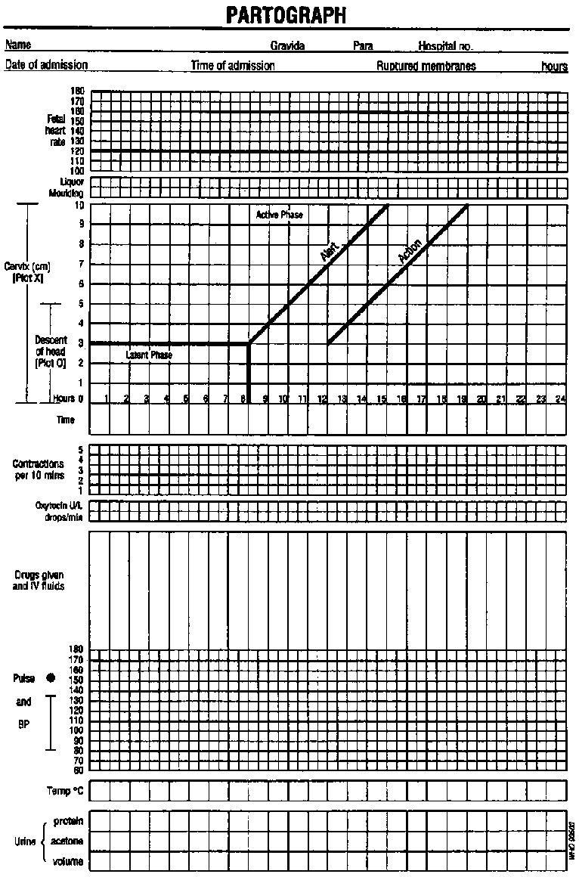

Appendix D Pseudo Code

public class Diagnosis extends Parameters {

String labour_is_obstructed;

String labour_is_active;

String Labour_not_Active;

String labour_is_prolonged;

Scanner in = new Scanner(System.in);

int n; double[] a; int min =4;

n= in.nextInt(); a= new double[n];

int i;

public Diagnosis(){ for(i=0;i<a.length;i++){ Parameters m = new Parameters();

m.getText().toString(); // get cervical dilatation a[i]= in.nextDouble();

if(a[i]>= min){ return labour_is_active;

}

else if(a[i]<min){ return Labour_not_Active;

} else if (a[i]==a[i-1]){ return labour_is_obstructed;

}

else if(a[i]>a[i-1] && a[i]<a[i-1]+min) { return labour_is_prolonged;

}

}

}

}